**DAILY ONLINE ACTIVITIES SUMMARY**

|  |  |  |  |  |  |  |  |  |
| --- | --- | --- | --- | --- | --- | --- | --- | --- |
| **Date:** | **29-06-2020** | | | | | **Name:** | **Huda Sultana** | |
| **Sem & Sec** | **8 A** | | | | | **USN:** | **4AL16CS039** | |
| **Online Test Summary** | | | | | | | | |
| **Subject** | | **-** | | | | | | |
| **Max. Marks** | | **-** | | **Score** | | | **-** | |
| **Certification Course Summary** | | | | | | | | |
| **Course** | **Introduction to Dedicated Instances.** | | | | | | | |
| **Certificate Provider** | | | **AWS** | | **Duration** | | | **30 mins** |
| **Coding Challenges** | | | | | | | | |
| **Problem Statement:**   1. **Write a C Program to removing empty spaces from string** | | | | | | | | |
| **Status: Solved** | | | | | | | | |
| **Uploaded the report in Github** | | | | | **Yes** | | | |
| **If yes Repository name** | | | | | **Hudasulltana/online_coding** | | | |
| **Uploaded the report in slack** | | | | | **Yes** | | | |

Online Test Details:

Not Conducted

Certification Course Details:

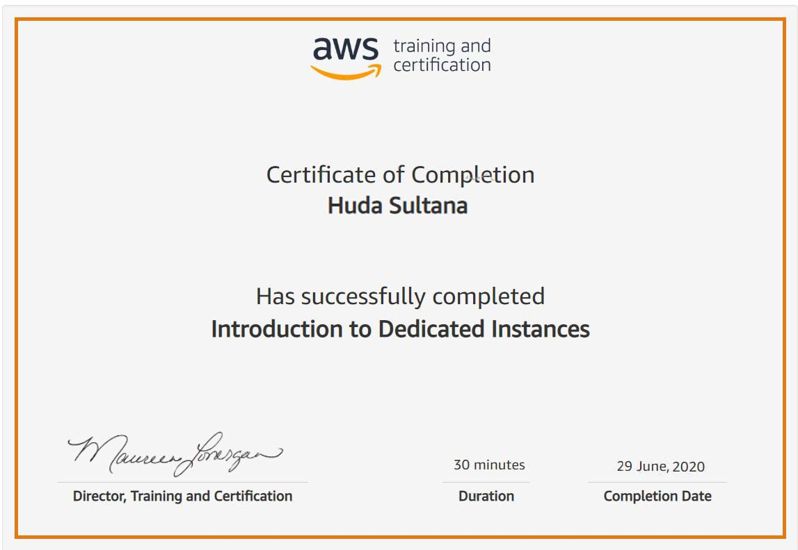

Coding Challenges Details:

**PROGRAM 1 .**

**//removing empty spaces from string**

**#include<stdio.h>**

**#include<string.h>**

**void main()**

**{**

**char str[80];**

**int i=0, len, j;**

**printf("Enter the String : ");**

**gets(str);**

**puts(str);**

**len=strlen(str);**

**for(i=0; i<len; i++)**

**{**

**if(str[i]==' ')**

**{**

**for(j=i; j<len; j++)**

**{**

**str[j]=str[j+1];**

**}**

**len--;**

**}**

**}**

**printf("String after removing spaces = %s", str);**

**return 0;**

**}**